**NFCSD Art Educator**

**Grade 6 – *Earth Art – Mandela***

**To Know:**

**Earth art** is an art movement in which landscape and the work of art are intricately linked. It is

also an [art](http://en.wikipedia.org/wiki/Art) form that is created in [nature](http://en.wikipedia.org/wiki/Nature), using [natural materials](http://en.wikipedia.org/wiki/Natural_materials) such as [soil](http://en.wikipedia.org/wiki/Soil), [rock](http://en.wikipedia.org/wiki/Rock_(geology)) (bed rock, boulders, stones…), organic media (logs, branches, [leaves](http://en.wikipedia.org/wiki/Leaf)…), and [water](http://en.wikipedia.org/wiki/Water). Sculptures are not placed in the landscape; rather, the landscape is altered to be the creation. Part of the fun of being an **environmental artist** is to leave a “Happy Surprise” for someone else to come along and find, like many environmental and street artists of the world do.

**Optional further study:** search the Earth Art of *Andy Goldsworthy*

**Supplies:** Stuff you can find from nature

**Optional Supplies:** Something to hold the items you collect; to move them to where you are creating. A cell phone to take a picture of your creation or whatever you’d like to make sketch of it; like a pencil & paper, if you want a keepsake of your work.

**To Do:**

*Take a walk in your yard, around your neighborhood, or at a park (remember to be at a safe distance, like 6 feet or more from others). Look for things that interest you (consider their *shape*, *color*, and *texture*), and collect multiples of them.

>> Art Secret: Odd numbers are easier to work with and pleasing to the eye <<

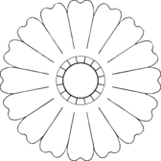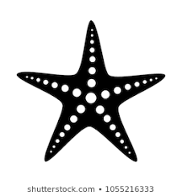*Find a good spot to create your radial design. At the park, your neighborhood or even on your front lawn. Then beginning in the center of that spot, create a repeating pattern moving both from the center and around a circle. Start with a clear ***focal point*** in the center, then, simply organize the elements to branch out from that central point keeping each branch with the same ***pattern*** as you move around the circle. This is called ***radial symmetry*** -

like a bicycle wheel, a starfish, a sunflower, and the sun.

**Mission Accomplished:**

Composed a **radial design**

**Radial Symmetry:**

**You can turn it, or walk around it and**

**it still looks the same**

* Circular overall shape
* Tighter toward the center
* Repetition throughout work

Organized thoughtful **color** choices

* Contrast with background &/or within design
* Repetition to enhance patterns

Craftsmanship **skills** are evident

* Artwork displays detail within patterns
* Clear, easy-to-read patterns and edges